**AEM AUthor component creation task**

**1.Creating author component:**

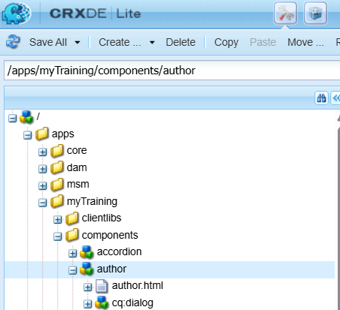

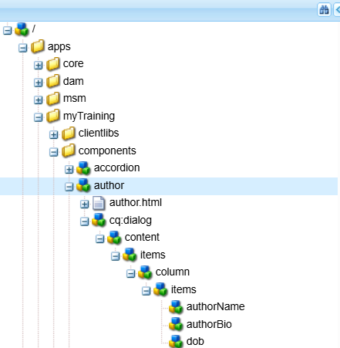**2. Creating node items for author name, date of birth, Bio in cq:dialog node**

**3.Adding properties for the nodes:**

Author Name:

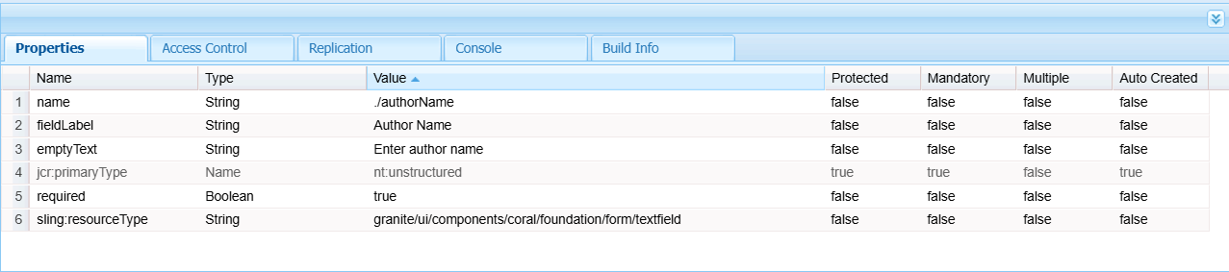

Author bio:

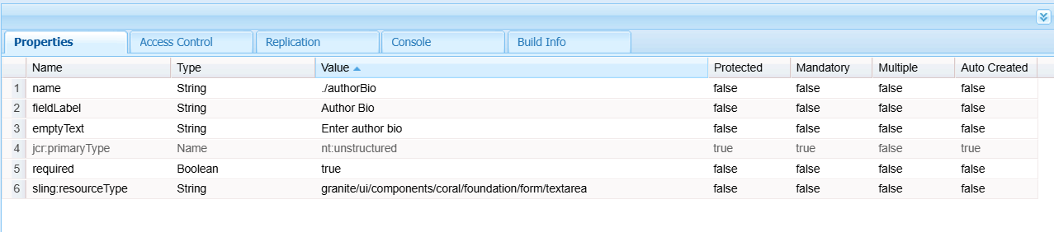

DOB:

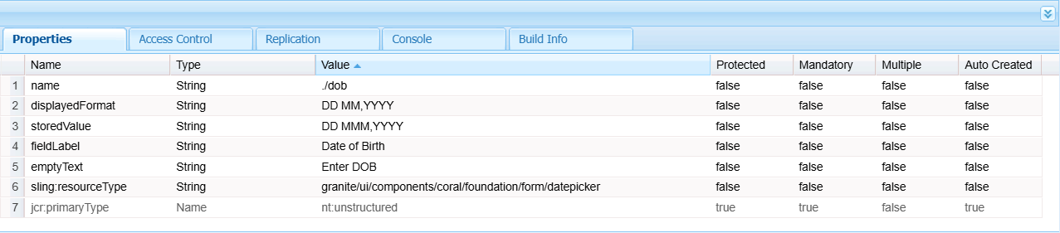

**4.Fetching values using HTL:**

author.html

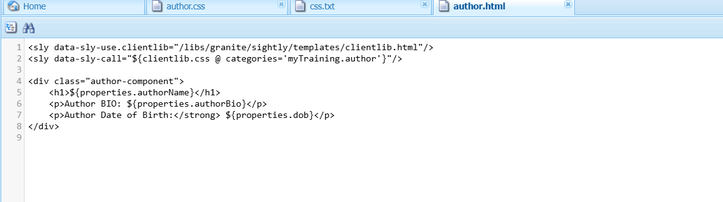

**5.Implementing client library:**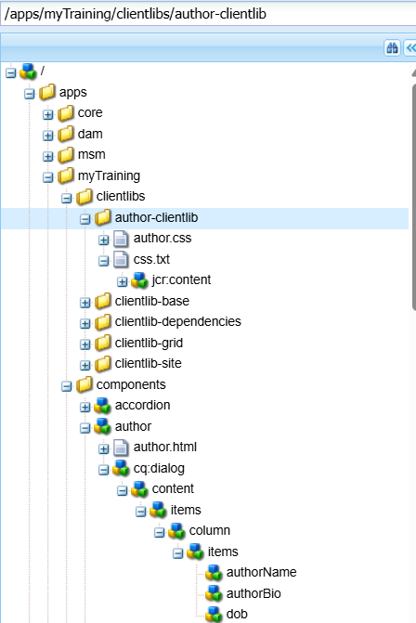

**5. Implementing author component:**

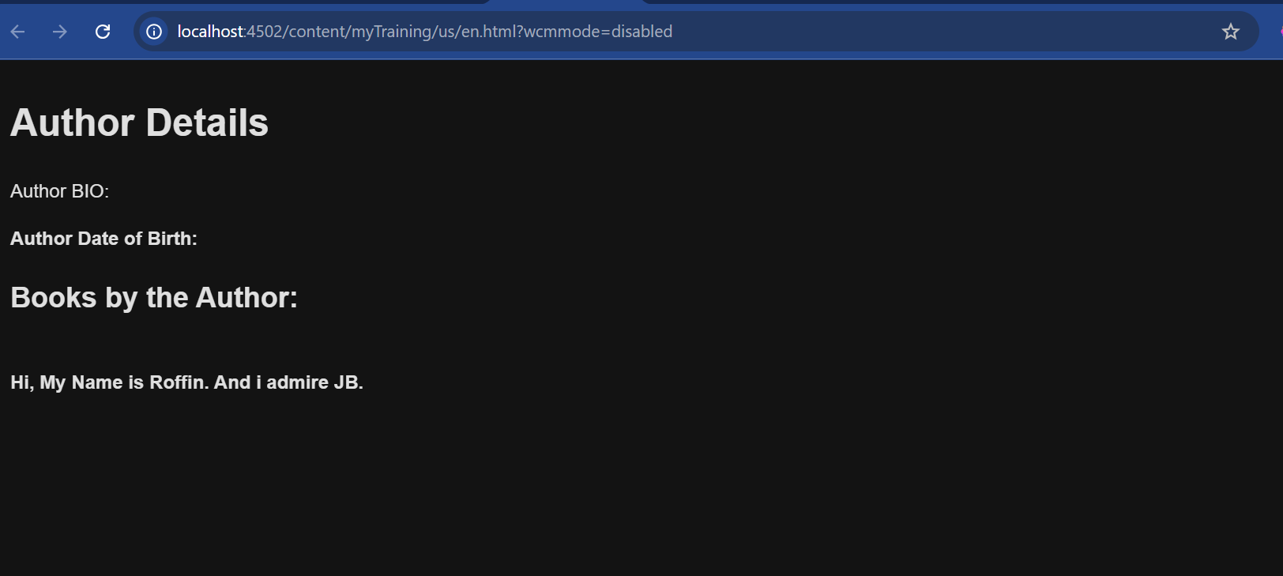

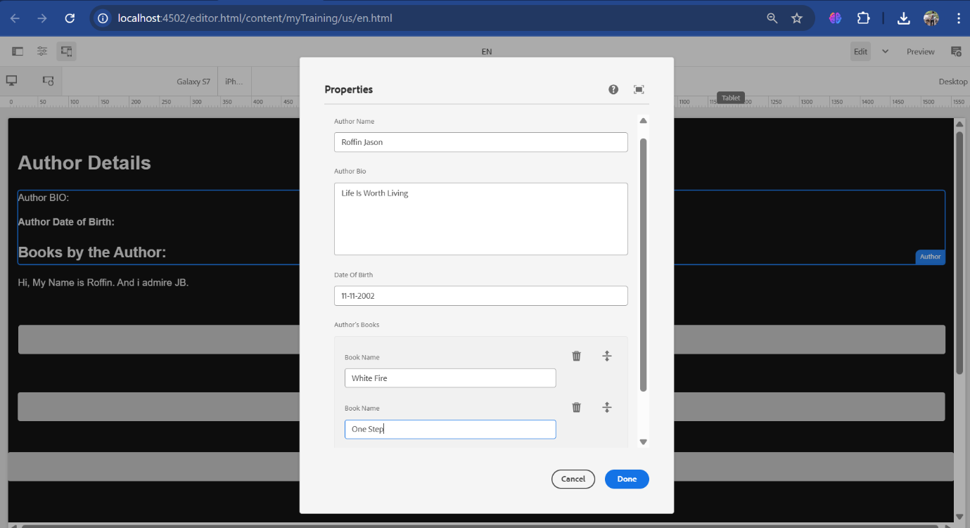

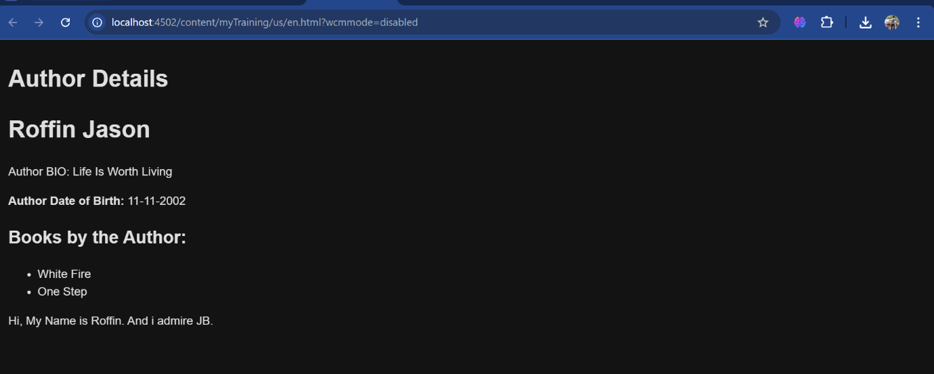

**6.What is Dialog Validation?**

*Dialog validation ensures that fields are correctly filled before saving the component. It can be enforced using the required attribute and validation patterns.*

**7.What is ClientLib?**

*Client Libraries (ClientLibs) manage CSS and JavaScript files in AEM. They improve performance and allow structured organization of front-end assets.*

**8.What is extraClientLib?**

*Extra Client Libraries allow specific styling or scripts to be loaded only when necessary. They can be created similarly to ClientLibs but with the extraClientLibs attribute.*